**User Requirements.**

I want a replica of [brand24.com](https://brand24.com/) with minimal requirements.

## **Get instant access to brand mentions across social, news, blogs, videos, forums, podcasts, reviews and more.**

# **Purpose of the Website.**

The purpose of this website is to provide user the ability for;

* Media Monitoring
* Tracking your Competition
* Grow Customer Business

# **Structure of the Website.**

* **Welcome Page.**

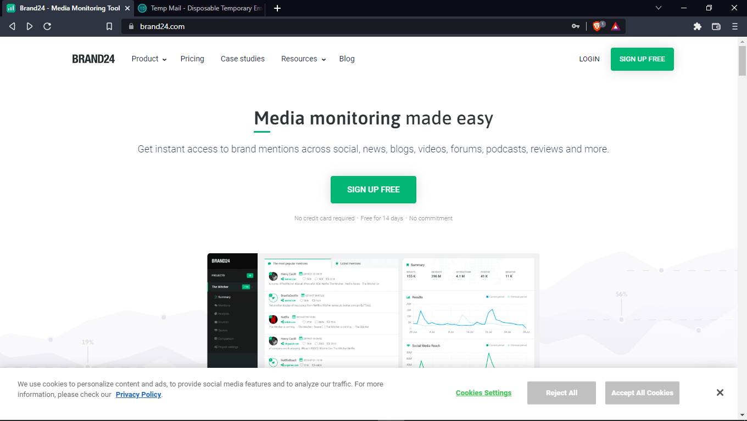

* **Sign Up Page.**

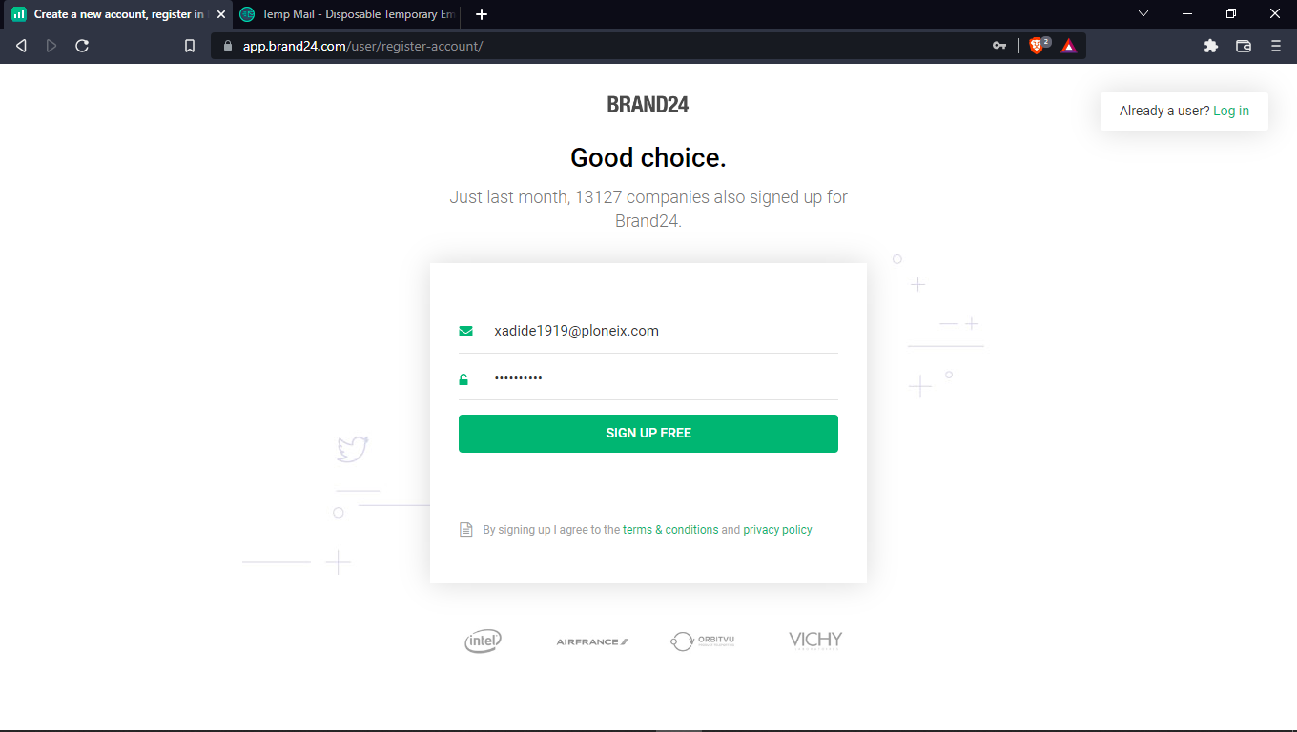

* **Log In Page.**

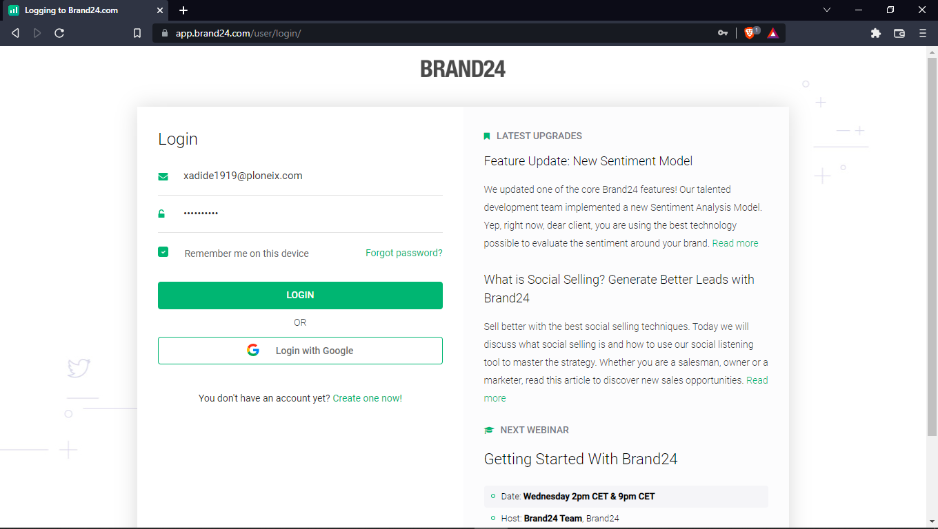

* **Create Project Page.**

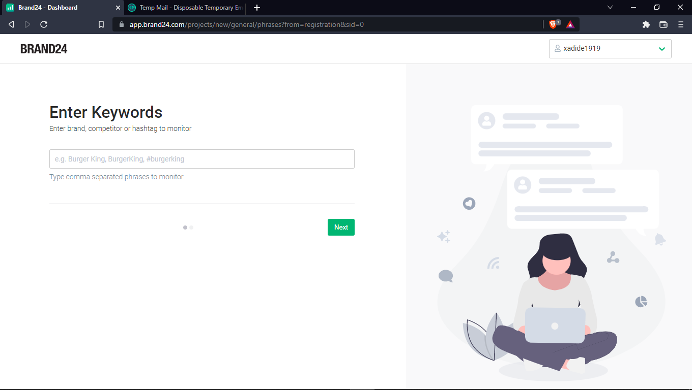

* **Display Mentions Page**

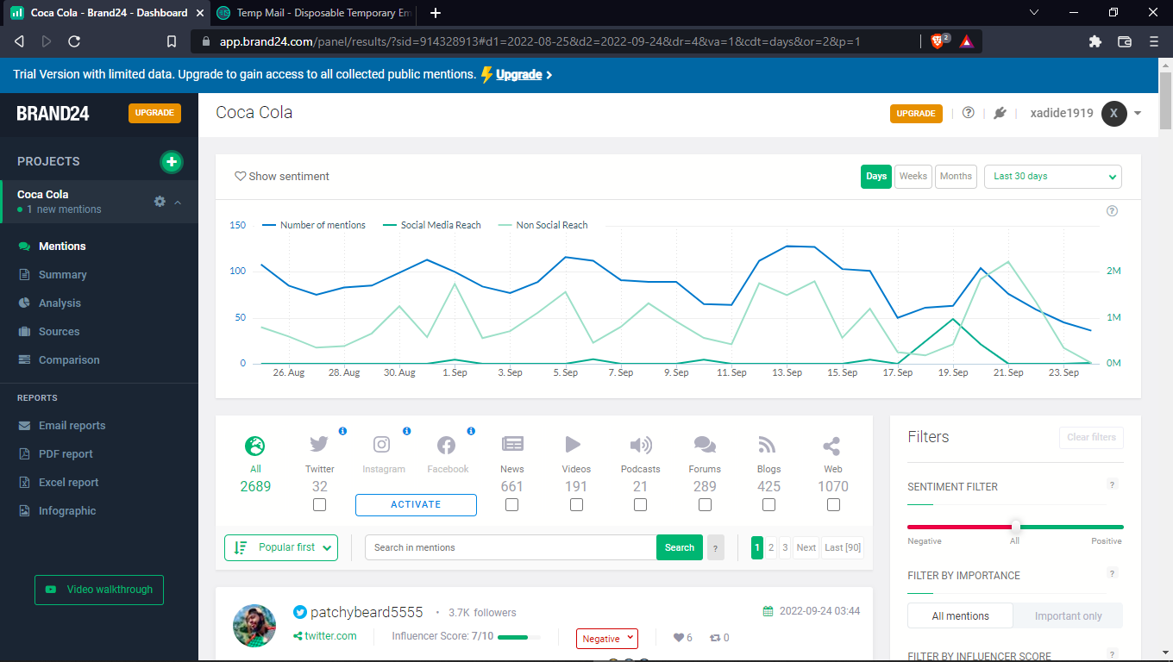

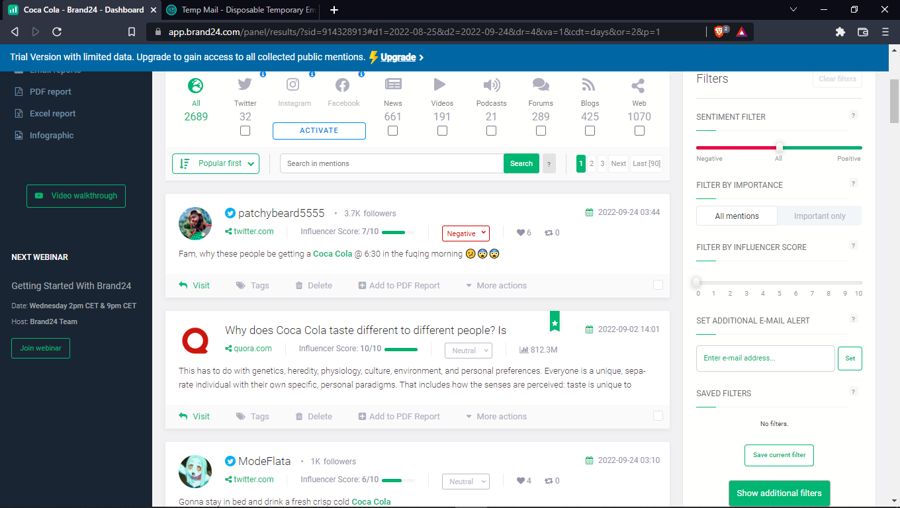

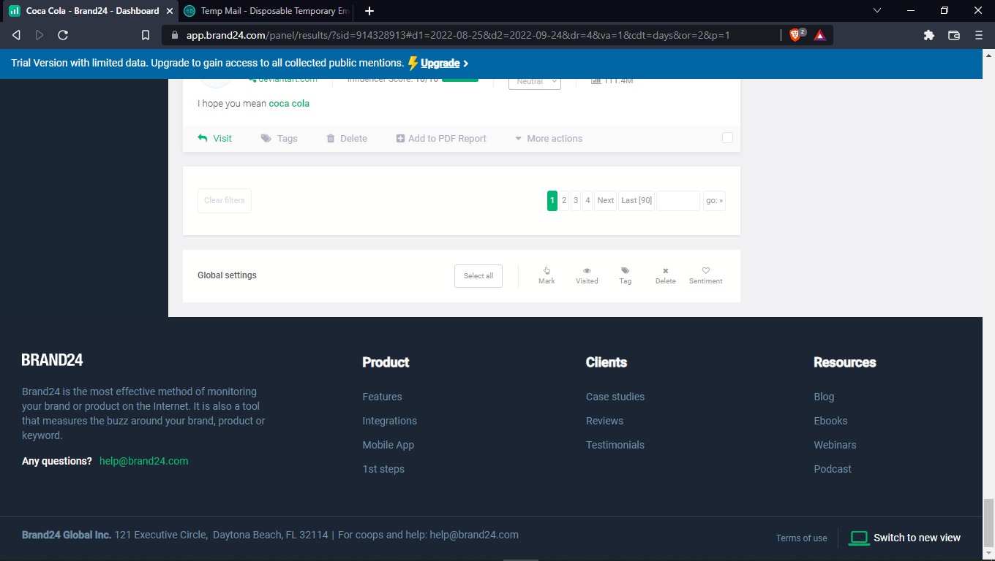

* **Comparison Page.**

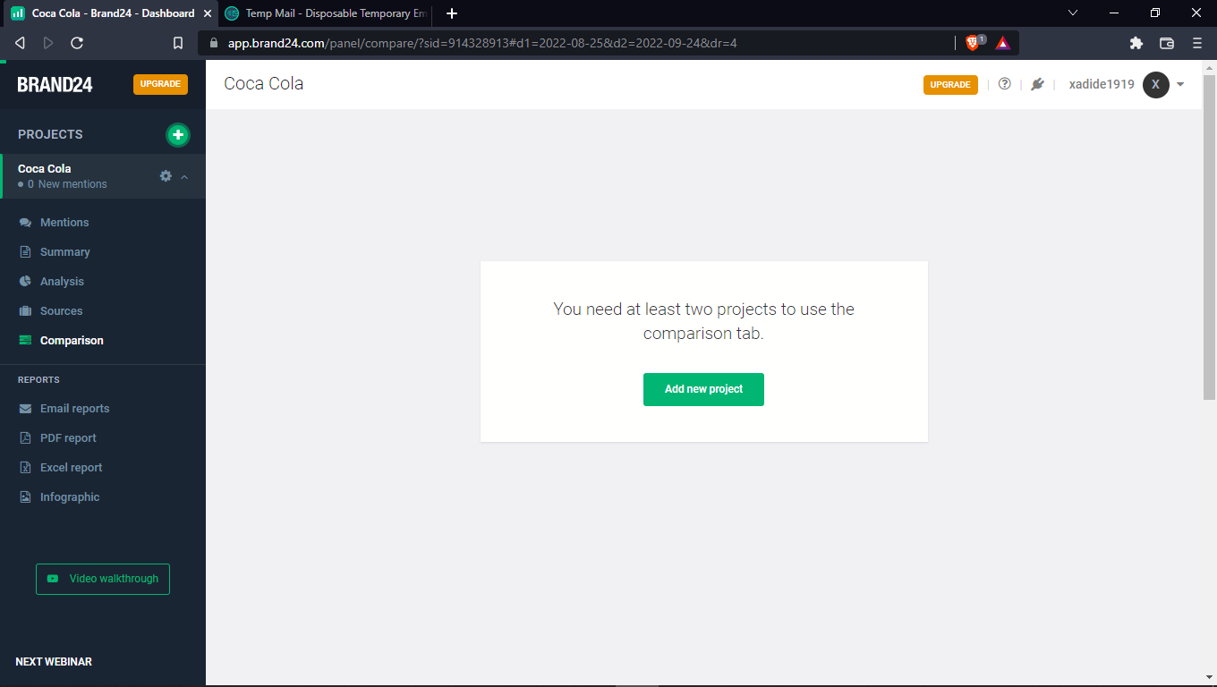

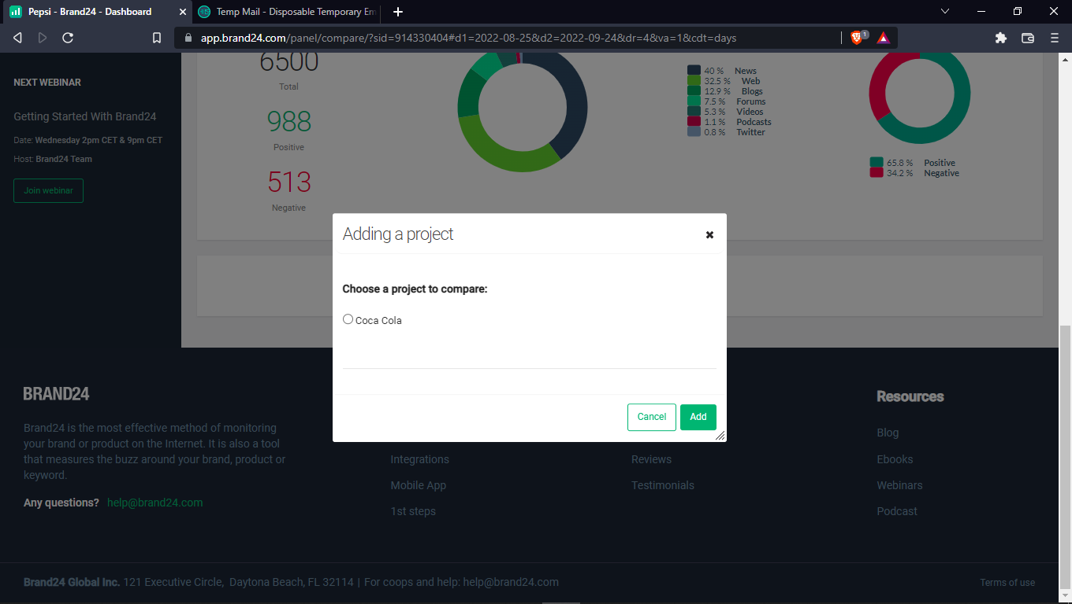

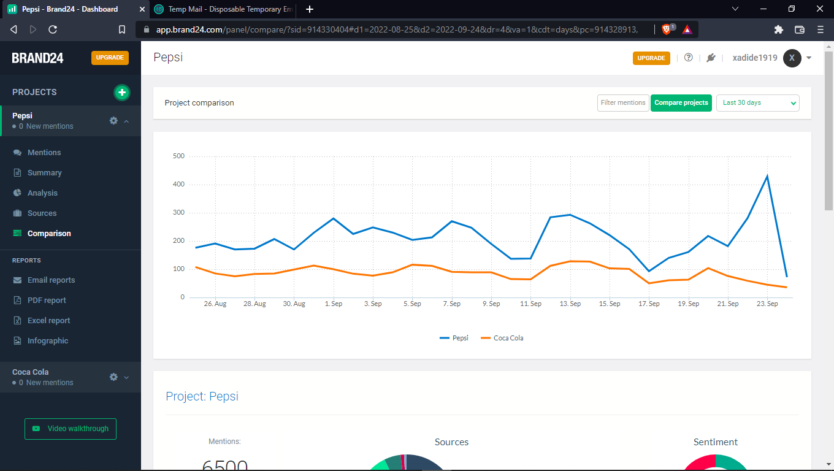

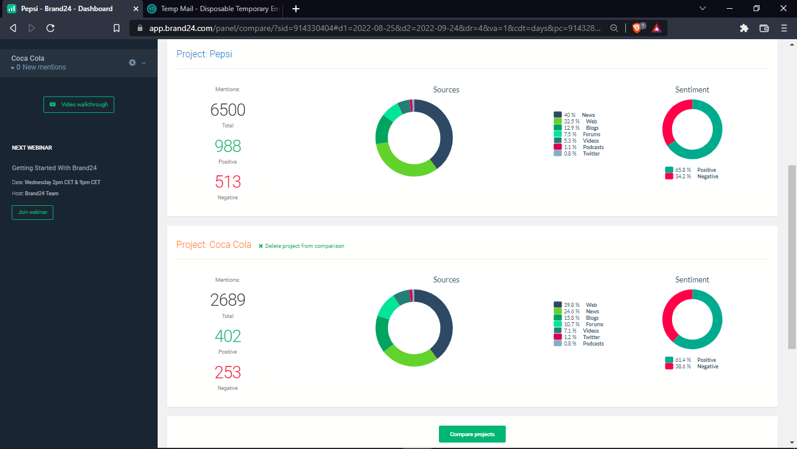

* **Dashboard Page.**

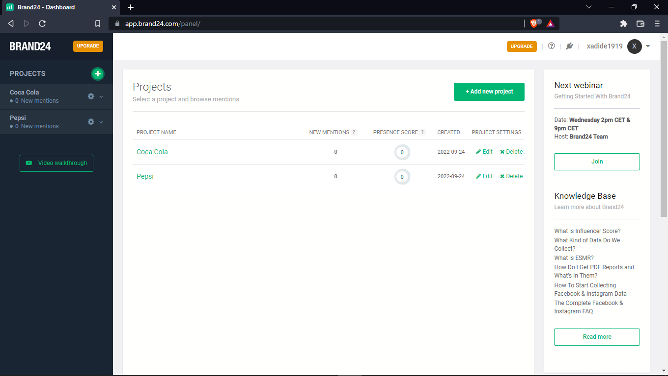

* **Generate Reports.**
  + **Email Reports.**
  + **PDF Reports.**
  + **Infographic Reports.**